Data Collection and Preprocessing Phase

Date | 5 th July 2024
Team ID | 739719
Project Title | Garment Workers Productivity Predictions
Maximum Marks | 6 Marks

Preprocessing Template
The images will be preprocessed by Data collection,Handling missing values,Normalization,Data aggregation,Data splitting,Visualization,Data storage,Documentation.This template provides a concise yet complete approach to preprocessing a dataset in preparation for machine learning.

Section | Description
Project Overview | Brief description of the project and its goals.
Data Collection | List of data sources and Types of data collected
Handling Missing Values | Techniques used (e.g., imputation, removal).
Normalization: | Procedures for scaling data
Data Aggregation: | Summarizing data to higher-level formats.
Data Splitting | Proportion of data split and Strategy used for cross-validation
Visualization Tools: | Tools and libraries used (e.g., Matplotlib, Seaborn).
Data Storage | Systems used for storing preprocessed data (e.g., SQL, NoSQL, cloud storage).
Documentation | Detailed documentation of all preprocessing steps for  reproducibility.and A comprehensive data dictionary  describing all variables and their transformations
Data Preprocessing Code Screenshots
Loading Data
Data Collection | 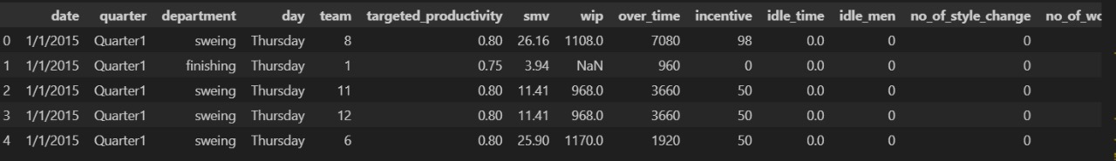
Handling Missing Values | 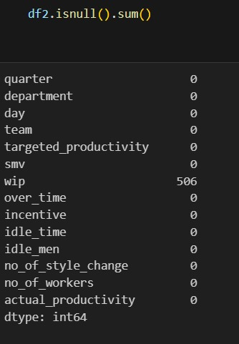
Normalization
Data Aggregation | 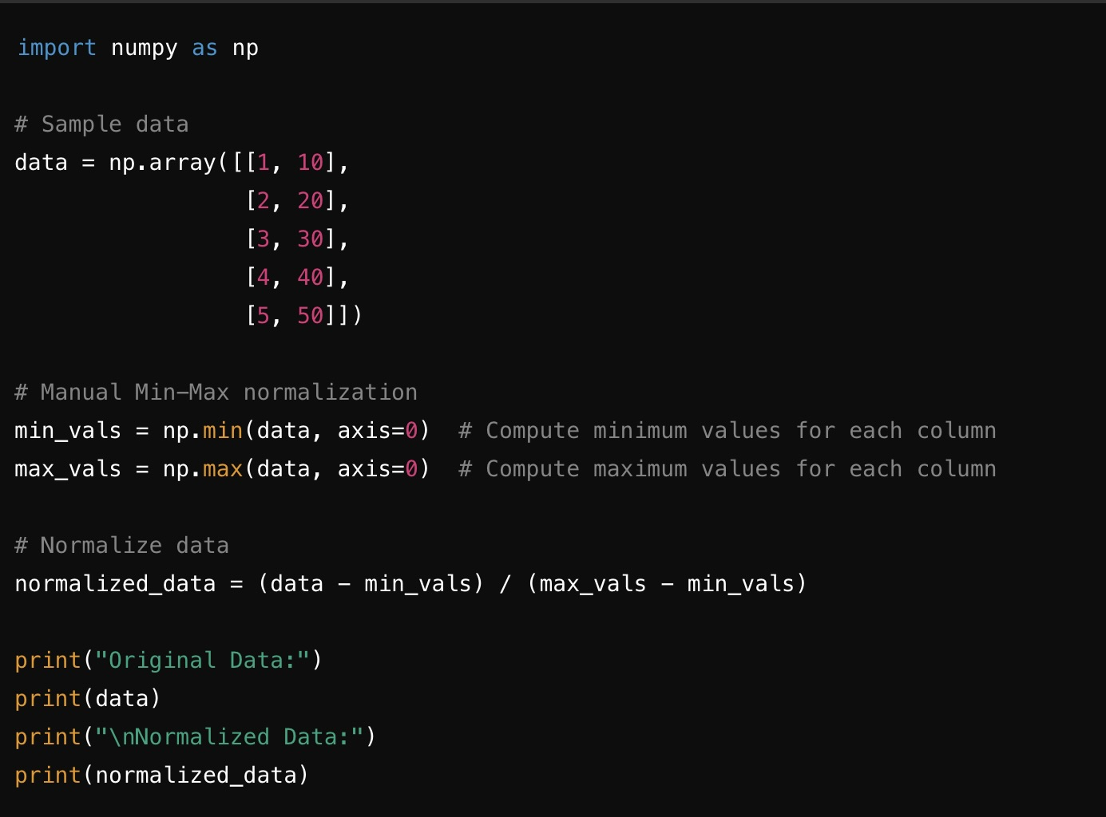
Data Splitting | 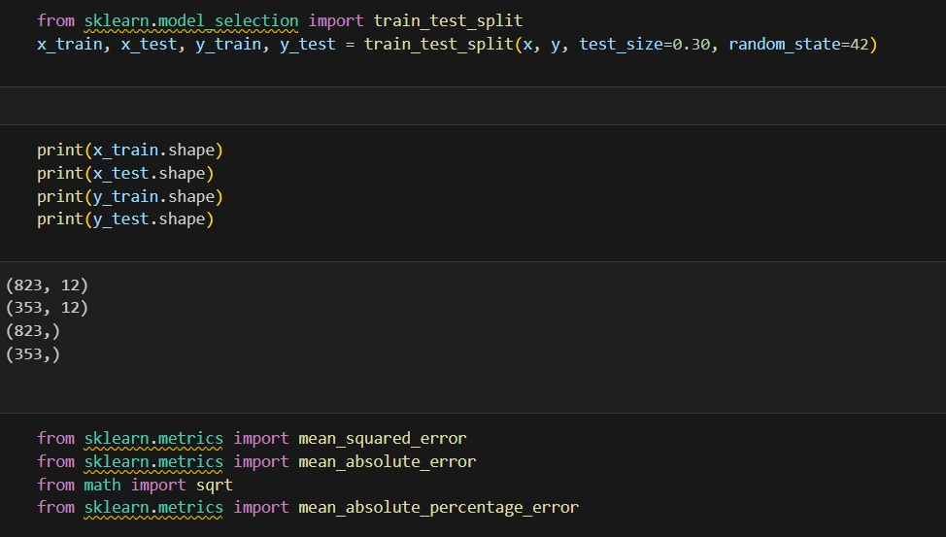
Visualization Tools: | 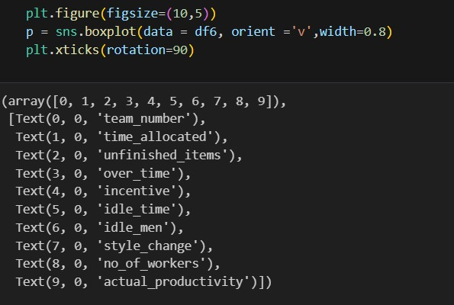
Data Storage | 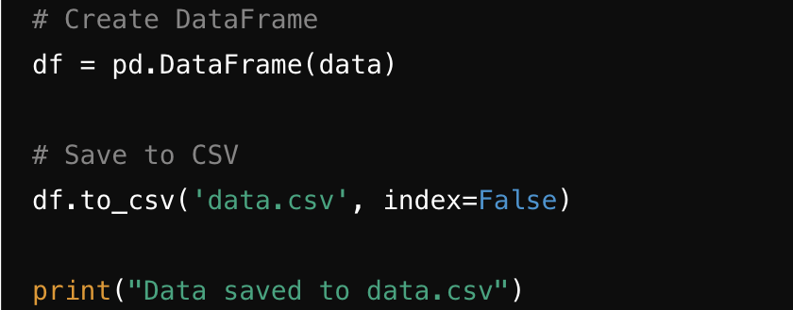
Documentation

